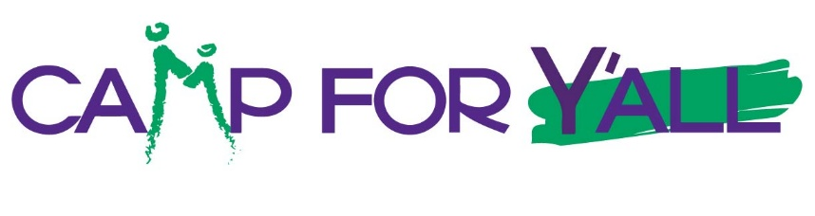
2026 Information & Pricing

Located in Burton, Texas, the 206-acre Camp For All site features more than 100,000 square feet of facilities, two lakes, nature trails, wooded areas, and areas for a wide range of activities. Camp For All was designed with no barriers for children and adults with special needs to experience the thrill of camping and nature, just like their able-bodied peers. More than 65 different nonprofit Partners bring their camps to Camp For All each year, with nearly 9,000 campers experiencing barrier-free fun.

For only the third time ever, Camp For All has designated Sunday, March 8 through Friday, March 13, 2026, as a special Camp For Y’All Week. That means you and your families and friends can experience Camp For All directly, either overnight or as a single-day option, and enjoy a variety of fun and safe activities led by our trained staff members. You don’t need to have an affiliation with one of our more than 65 nonprofit Partners.

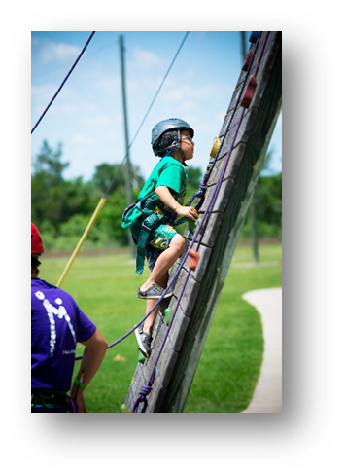
- Age to Participate. There is no minimum age to attend Camp For Y’All and stay in a cabin. Children 4 years old and older count as a person in a cabin. Ages 3 years old and under are free. Different activities, however, do have minimum age requirements for participating. Campers must be 6 years old or older to climb The Tower or participate in archery, the giant swing, and Star Place Ropes.

- Cabins and Accommodations. There are 18 air-conditioned cabins located at Camp For All. A maximum of 15 guests are allowed per cabin. There are 15 twin beds, three of which are bunk beds. Campers are required to bring their own pillows, toiletries, towels, and water bottles. All cabins have their own restroom and shower area.

You don’t have to be related to be considered a family. “Family” for the purposes of attending Camp For Y’All are people who will be sharing a cabin.

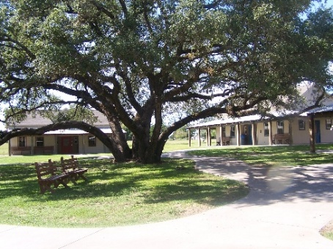
- Food and Beverage. Camp For All has a large Dining Hall with open seating and a talented food services team that is prepared to serve or meet almost any dietary need. Campers can bring coolers to store their own snacks and beverages. Alcohol may be consumed in cabins and at campfires for those 21 years of age and older. It also must be consumed from a tumbler or other shatterproof container. Campers aren’t allowed to participate in any activities after consuming alcohol.

- Schedule and Personal Items. Most of your stay will be free time to use as you choose. Each Camp activity will last about an hour. Mealtimes are set from 8-9 a.m., Noon-1 p.m., and 7-9 p.m. Parents are responsible for their children at all times, as there will be no childcare provided by Camp For All.

While campers are permitted to bring their own general personal items, such as flashlights, board games, bubbles, chalk, and toys, there are some restrictions. If you’re on a bike, skates, or a non-motorized scooter, you must wear a helmet. Wheeled personal items are for outdoor use only. For safety reasons, drones aren’t allowed when horseback riding or climbing activities are taking place.

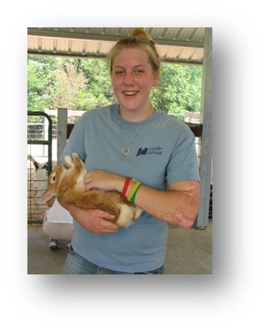
- Wi-Fi Connectivity. While we think you’ll be having way too much fun to even think about your mobile devices or laptops, there is limited Wi-Fi connectivity available in common gathering areas such as the Dining Hall and Star Place. Please don’t expect to have Wi-Fi access in the cabins or during outdoor activities.

- Pets. Pets aren’t allowed at Camp For All. But don’t worry, we have plenty of friendly animals to spend time with at Camp.

- Smoking. There is no smoking, vaping, or tobacco use allowed anywhere on Camp property.

- Reservations and Cancellations. Check-in time is between 4-8 p.m. Check-out time is 1 p.m. The cabins don’t lock, so you don’t need a key. Camp For All is not responsible for lost or stolen items.

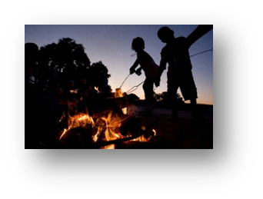
The cost per person for an overnight stay is $150. If you need to cancel your reservation, you’re eligible for a full refund if you cancel within 24 hours of making a reservation. For later cancellations, you’re eligible for 75% of the fee refunded if the cancellation is made at least 72 hours before your arrival. There will be no refunds within 72 hours of your stay.

If you prefer to visit Camp for just a day, single-day options are available for $75 per person. Campers can arrive any time after 8 a.m. and stay with us through the end of the evening program, which usually concludes around 9 p.m. All Camp activities and areas are available to campers who choose the single-day option. The same cancellation policy described above applies to day campers.

For more information about Camp For Y’All, please contact us at
979-803-3409 or reservations@campforall.org.

